**EMBASSY OF SWITZERLAND**

**TO THE UNITED ARAB EMIRATES AND BAHRAIN**

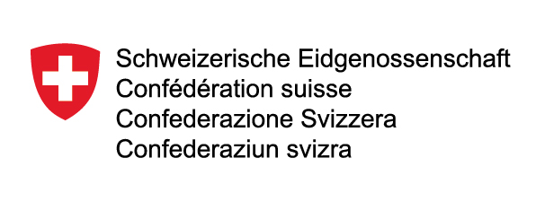

Application for Nominal Support

* Date of Request:

* Organisation Name:

* Name of Applicant:

* Title/Position:

* Address:

* Phone:

* Fax:

* E-mail:

* Event Name:

* Event Date and Time:

* Event Venue:

* Event Sponsor(s):

* Description of the purpose of the organization:

* Source of funding for the organization and for the specific project or event for which the Embassy’s nominal support is sought:

* Details of the specific project or event for which the Embassy’s nominal support is sought:

* Description of relationship of the specific project or event with Switzerland:

* Information on the expected participants/audience of the project or event for which the Embassy’s nominal support is sought:

* Specific purposes to which the Embassy’s nominal support will be used – e.g. use in publicity material:

* Full details of any other organizations or agencies from whom nominal support to this project or event is sought and their responses:

* Other references:

* Contact person and email address:

Please send this application form by post, fax or email

Embassy of Switzerland

P.O. Box 46116

Abu Dhabi – UAE

Fax: + 971 2 626 96 27

E-mail: abudhabi@eda.admin.ch